POST MORTEM

INPUT OUTPUT

2019

by: Pieter Winderlich

Preface:

This is my report on my Input/output project of 2019.

This project was about being able to handle special input such as :hand movement , Facial recognition or making your own controllers.

I am also convinced that the actual purpose of this project is to show that we can actually program something without Unity holding our hand, since Unity was explicitly forbidden.

I felt like I could take the challenge and make something epic.

Process:

The first thing I did was decide what language I wanted to use.

I ended up with java as my decision.

*Software:*

I had a lot of issues with installing Java. First of all , I installed the JDK which gave me the error of not finding the runtime environment. Teachers gave me the advice to switch to raw C# and I thought I fixed it, But life is not this easy. This took me 2 days to try to fix before rerouting my course. They gave me the advice to use intellij. I installed intellij hoping it would be fixed. I was wrong. It gave me several more issues since it could not find my runtime environment. I went to my teachers for help since I was losing too much time to this and was hoping that I would have been granted mercy by Java. It took me 8 days to actually get java to run properly. Meanwhile I made a class diagram to have my code at least organized when I could start programming. This helped me tremendously.

I created my setup framework after re-learning java a bit only to find a new issue. It did not want to load my images. It gave me a runtime error and did not know how to fix it since the answers on the internet where scarce at best. I asked a classmate to help me and together we figured out that he did not want to take my Url properly. The trail went cold after that and it was during the weekend so no help from teachers. I waited till monday for help when it took me and my teachers an entire day for a solution which went a bit like this

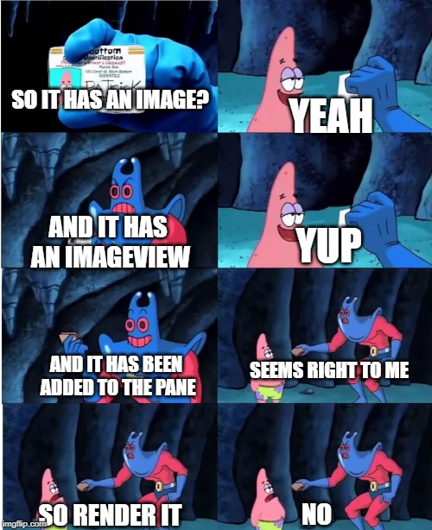

After 2 hours I figured a solution. It turns out that intellij looks for objects/classes/images from the src folder. No answers about this on the internet. By this time it was time to work on my controller according to my time schedule . so for the time being I let it be and started to work on my Controller. After the controller was finished I tried to build the game as fast as possible. Without issue I created a level , Enemies , the player and movement. I had some issues with the shooting, where the would fire to often during input. This was an issue I could not fix in time.

The end product has random spawning enemies, A moving player and the player can shoot.

In my opinion I could have maybe put a bit more effort into it but the issues that came up where very unexpected since I had no issues like this with Java in the past. It was a great decision to make a class diagram, else I would have barely anything.

For my hardware I chose the Makey Makey.

*Hardware:*

This went Very well. My first acton was to sketch my design. I am not good with drawing at all and it took me a couple of tries but I got a result I was proud of

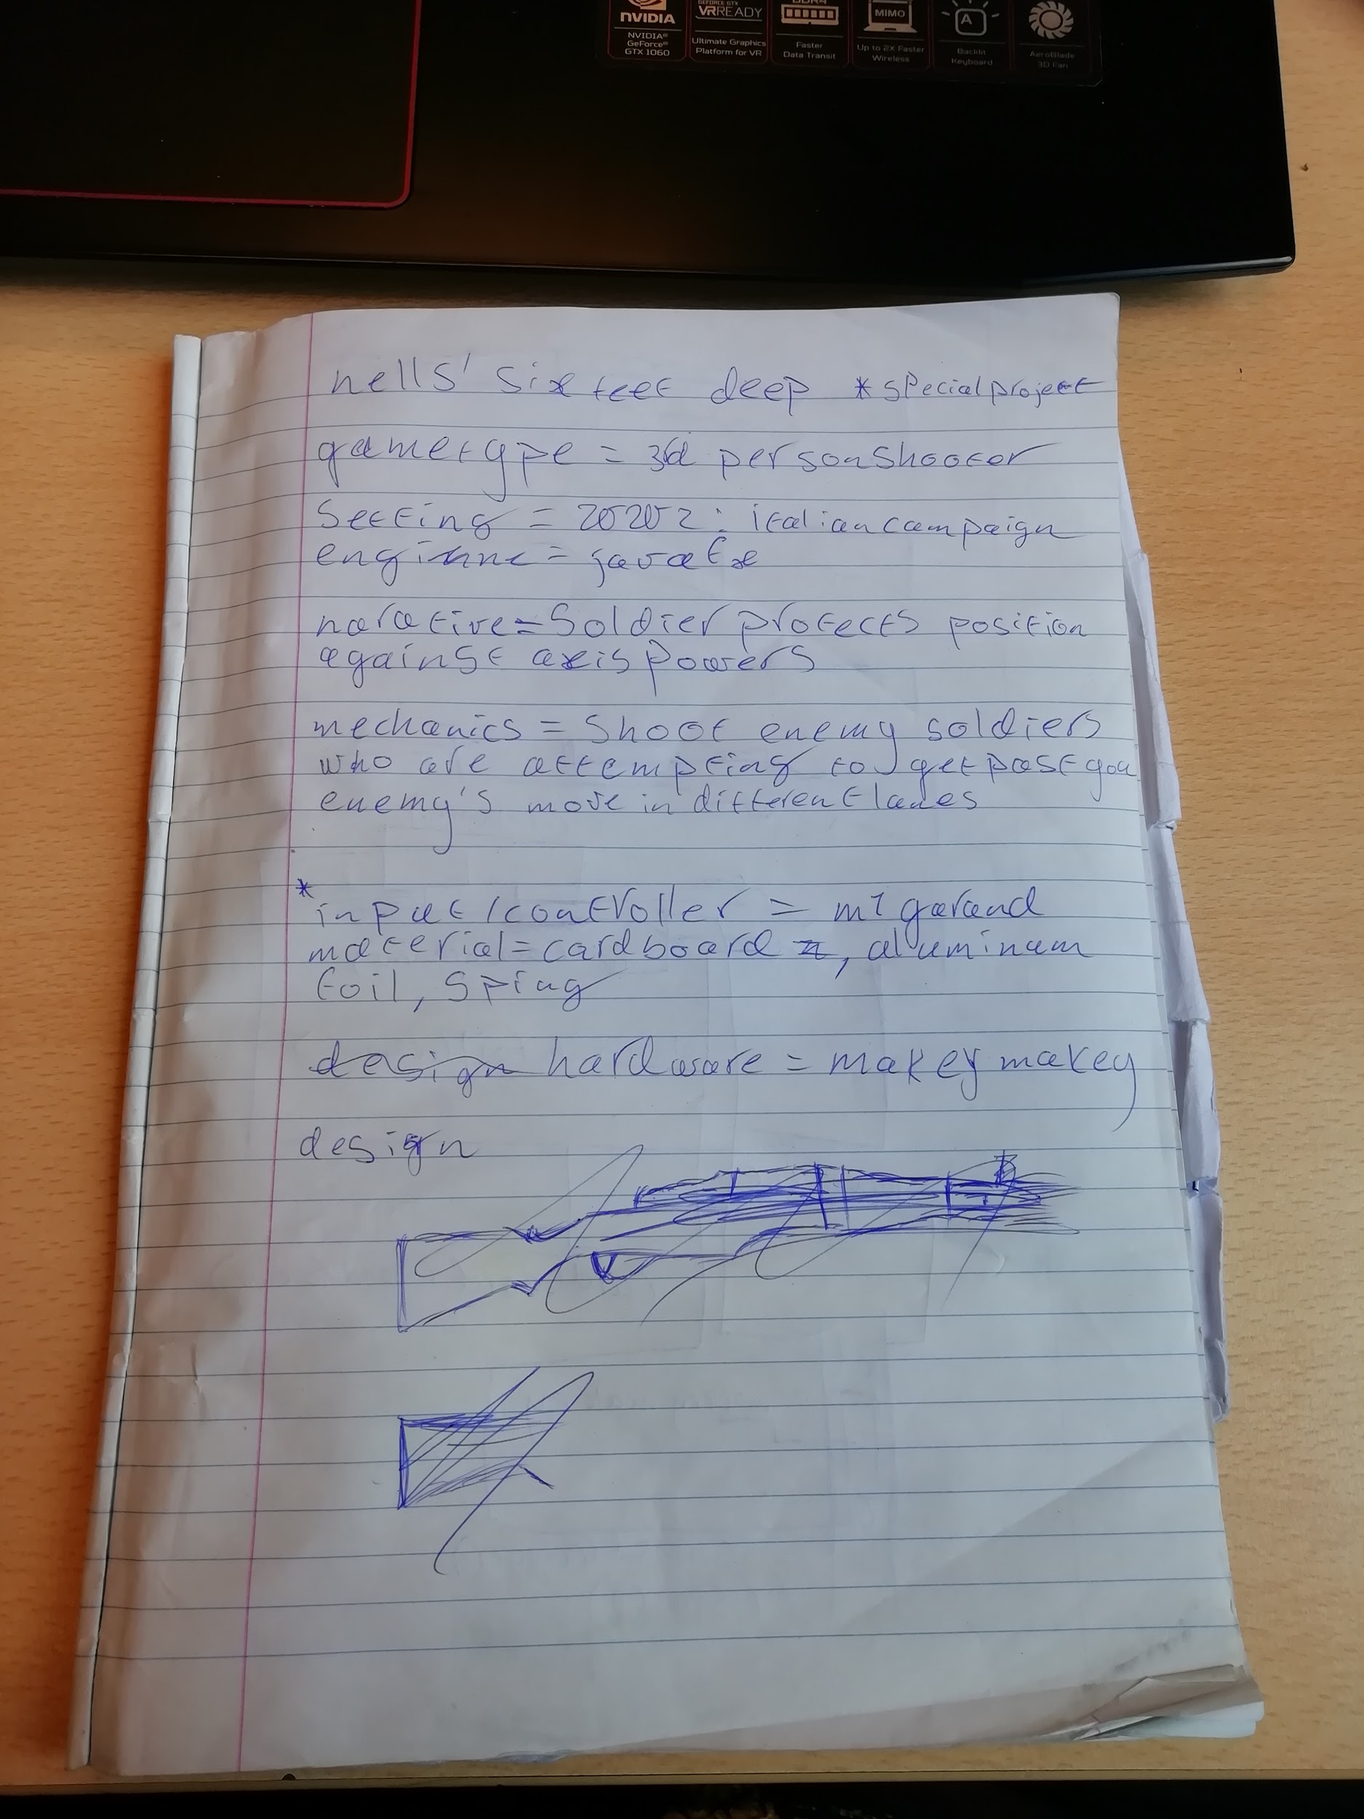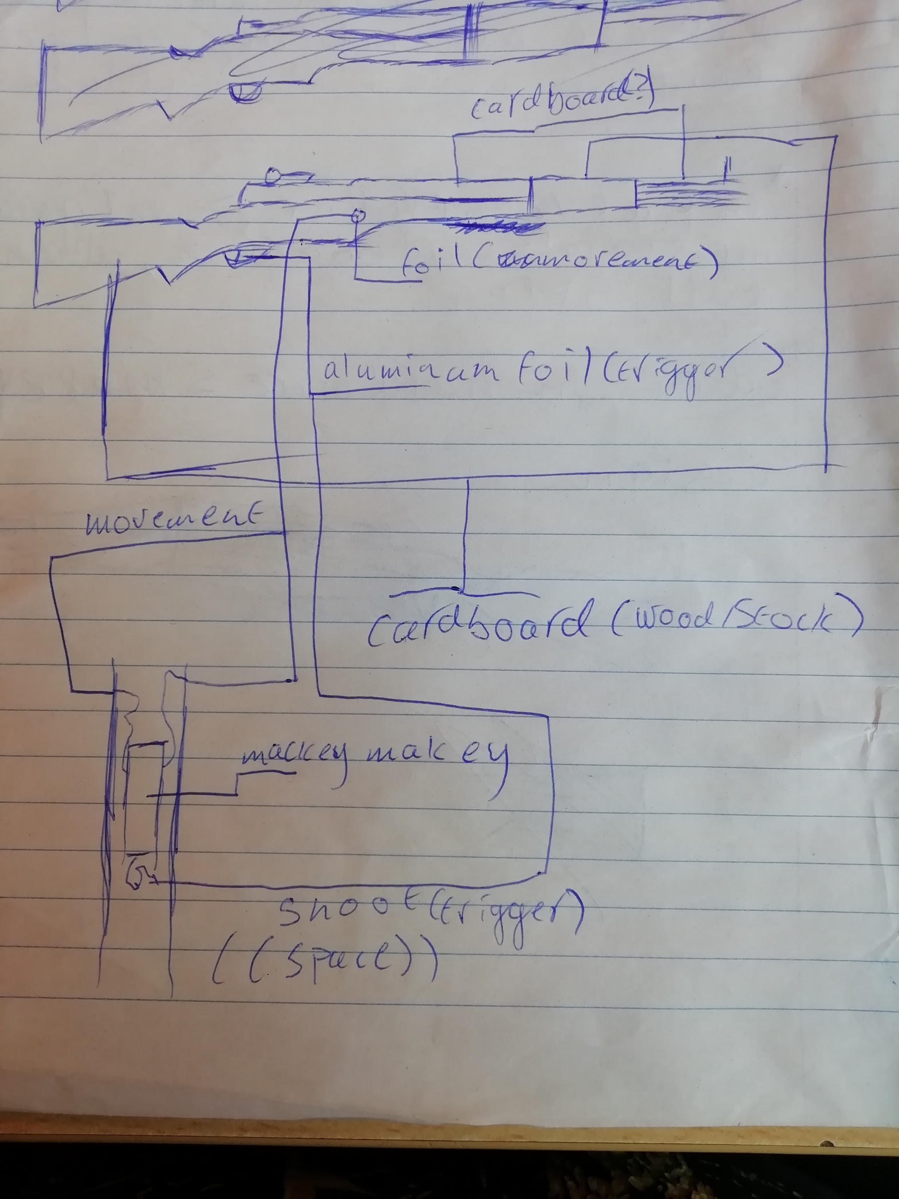

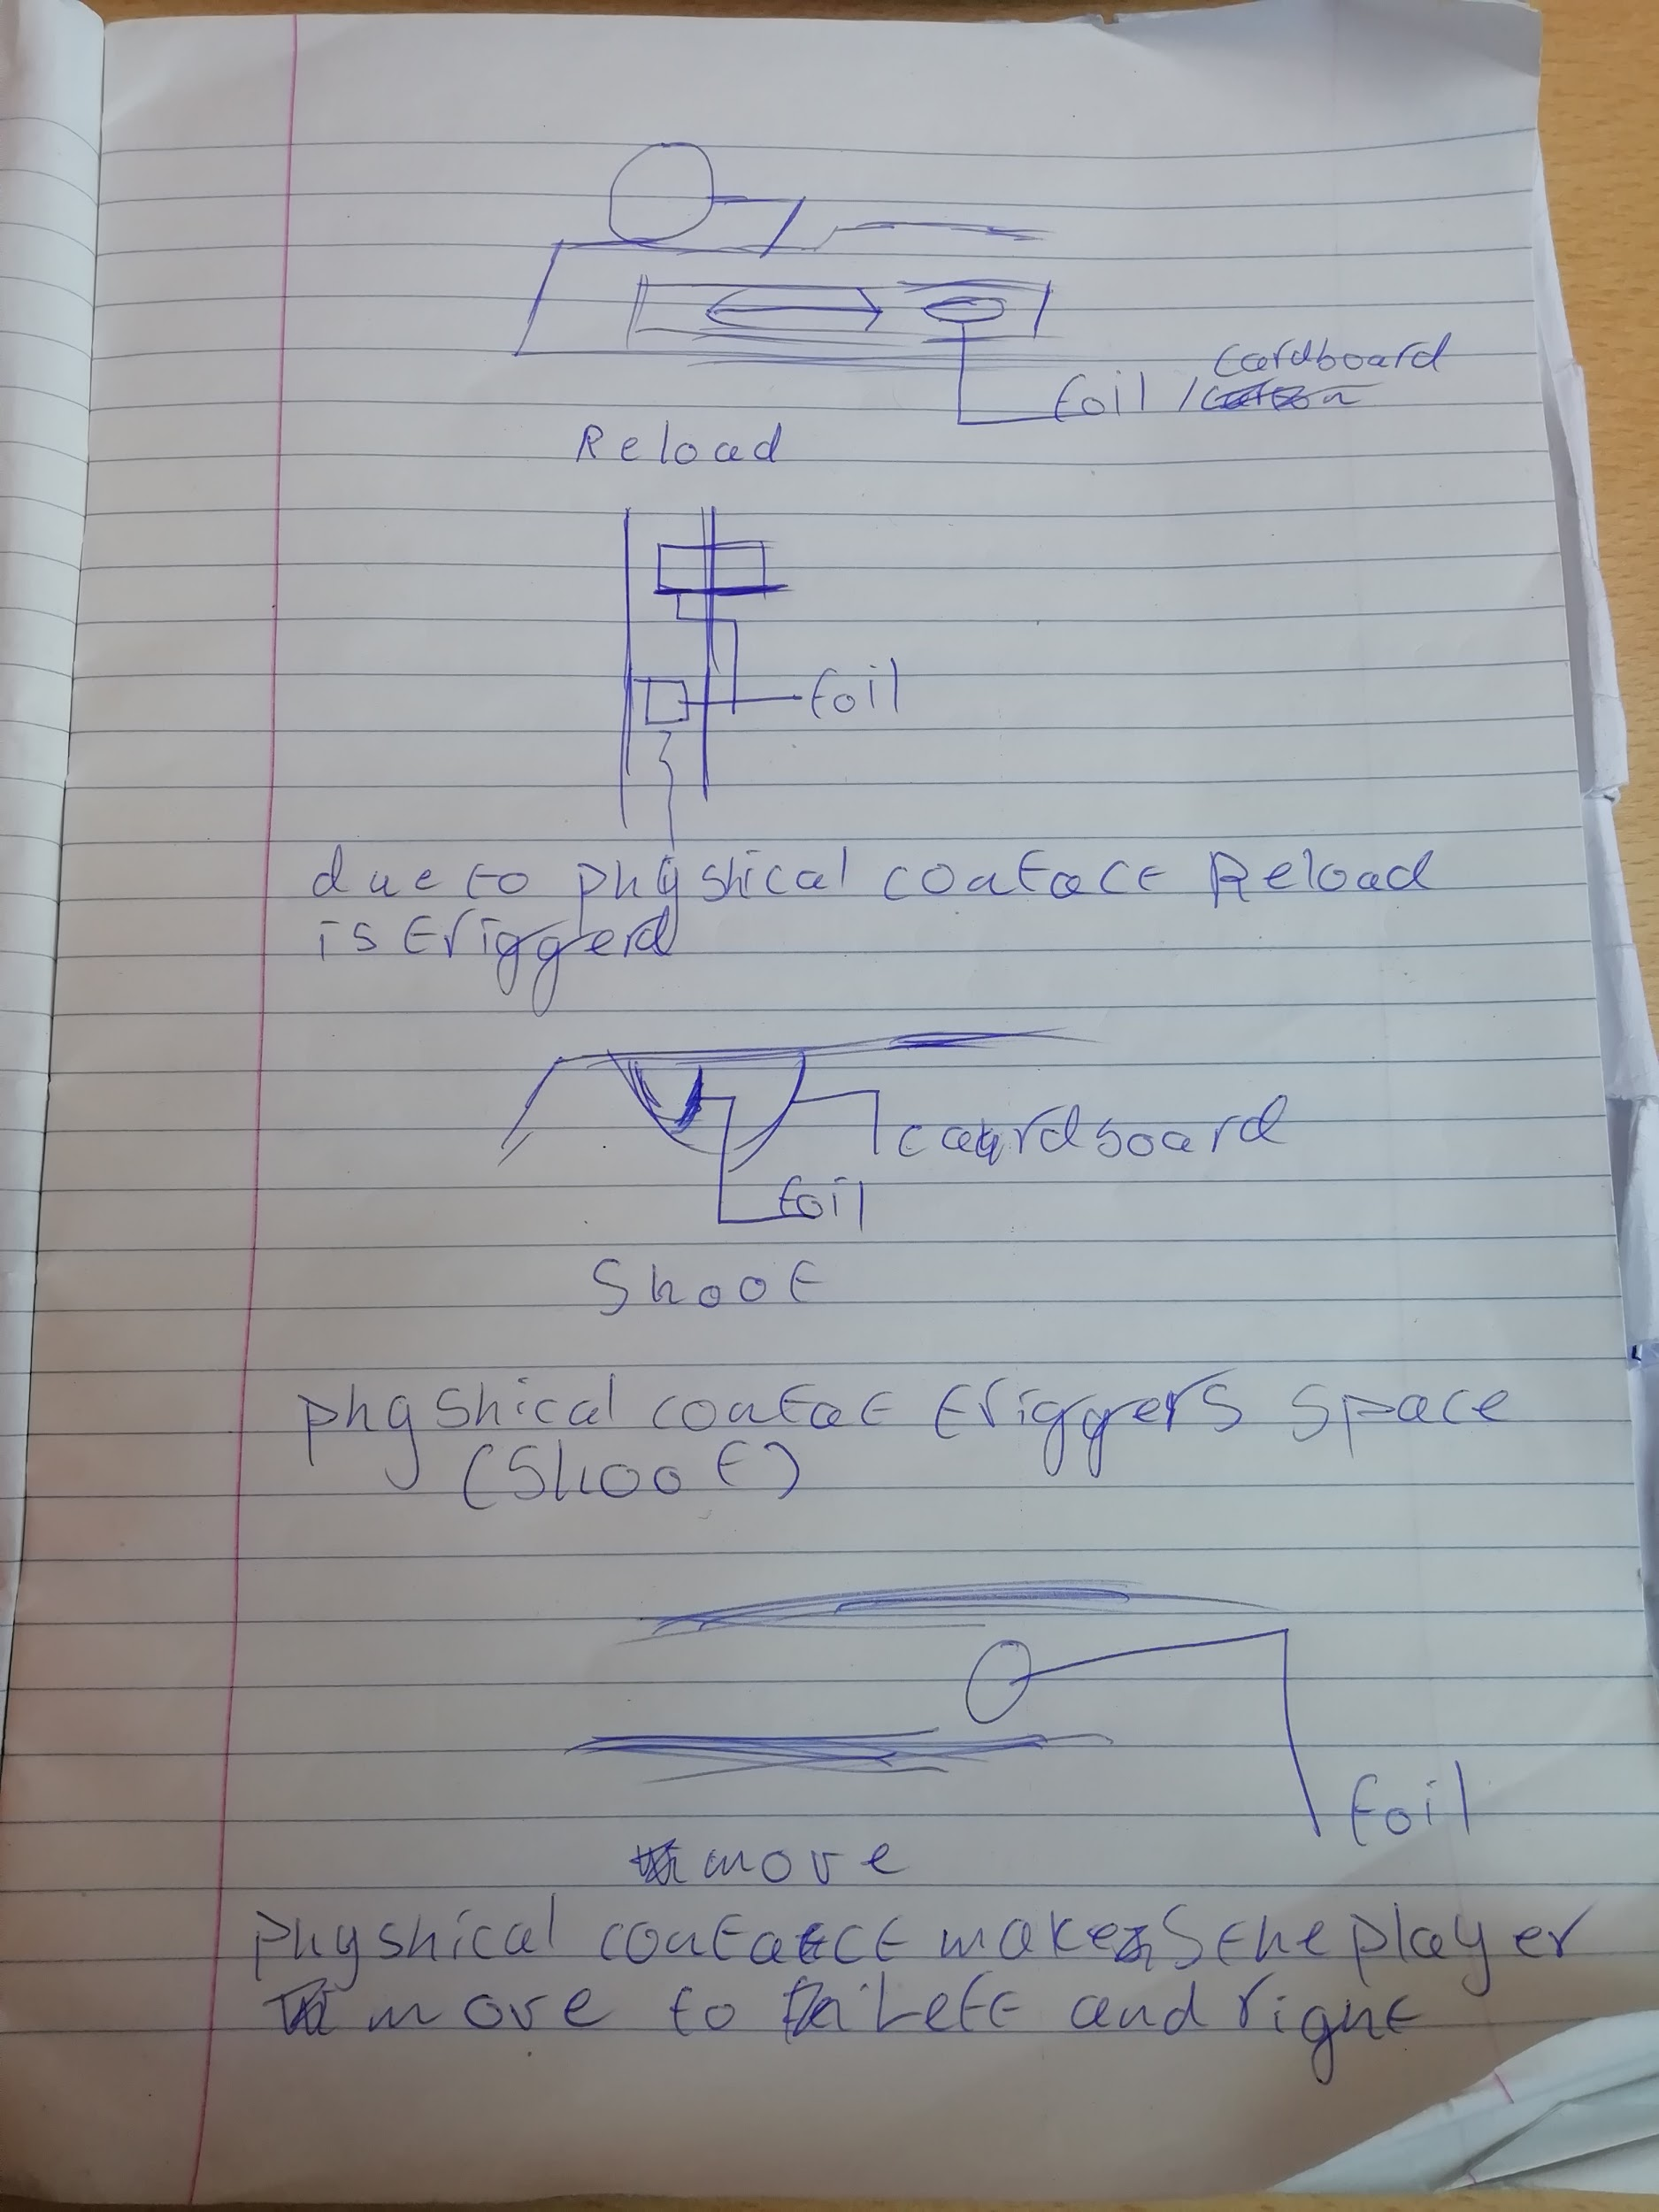

As per schedule, I would build the controller in the last 2 weeks. This was plenty of time. the design held up during construction and I added some duct tape to reinforce the model. The testing phases went spiffingly although some parts broke down. This was due to me using a glue stick instead of building glue. The first part was cosmetic so not important but the second was my reload system. This took me 2 hours to fix since I had to recreate my entire reload system. The result was worth all the frustration and anger since it has been an absolute joy to see so many people impressed with my work and it actually operating as it should.

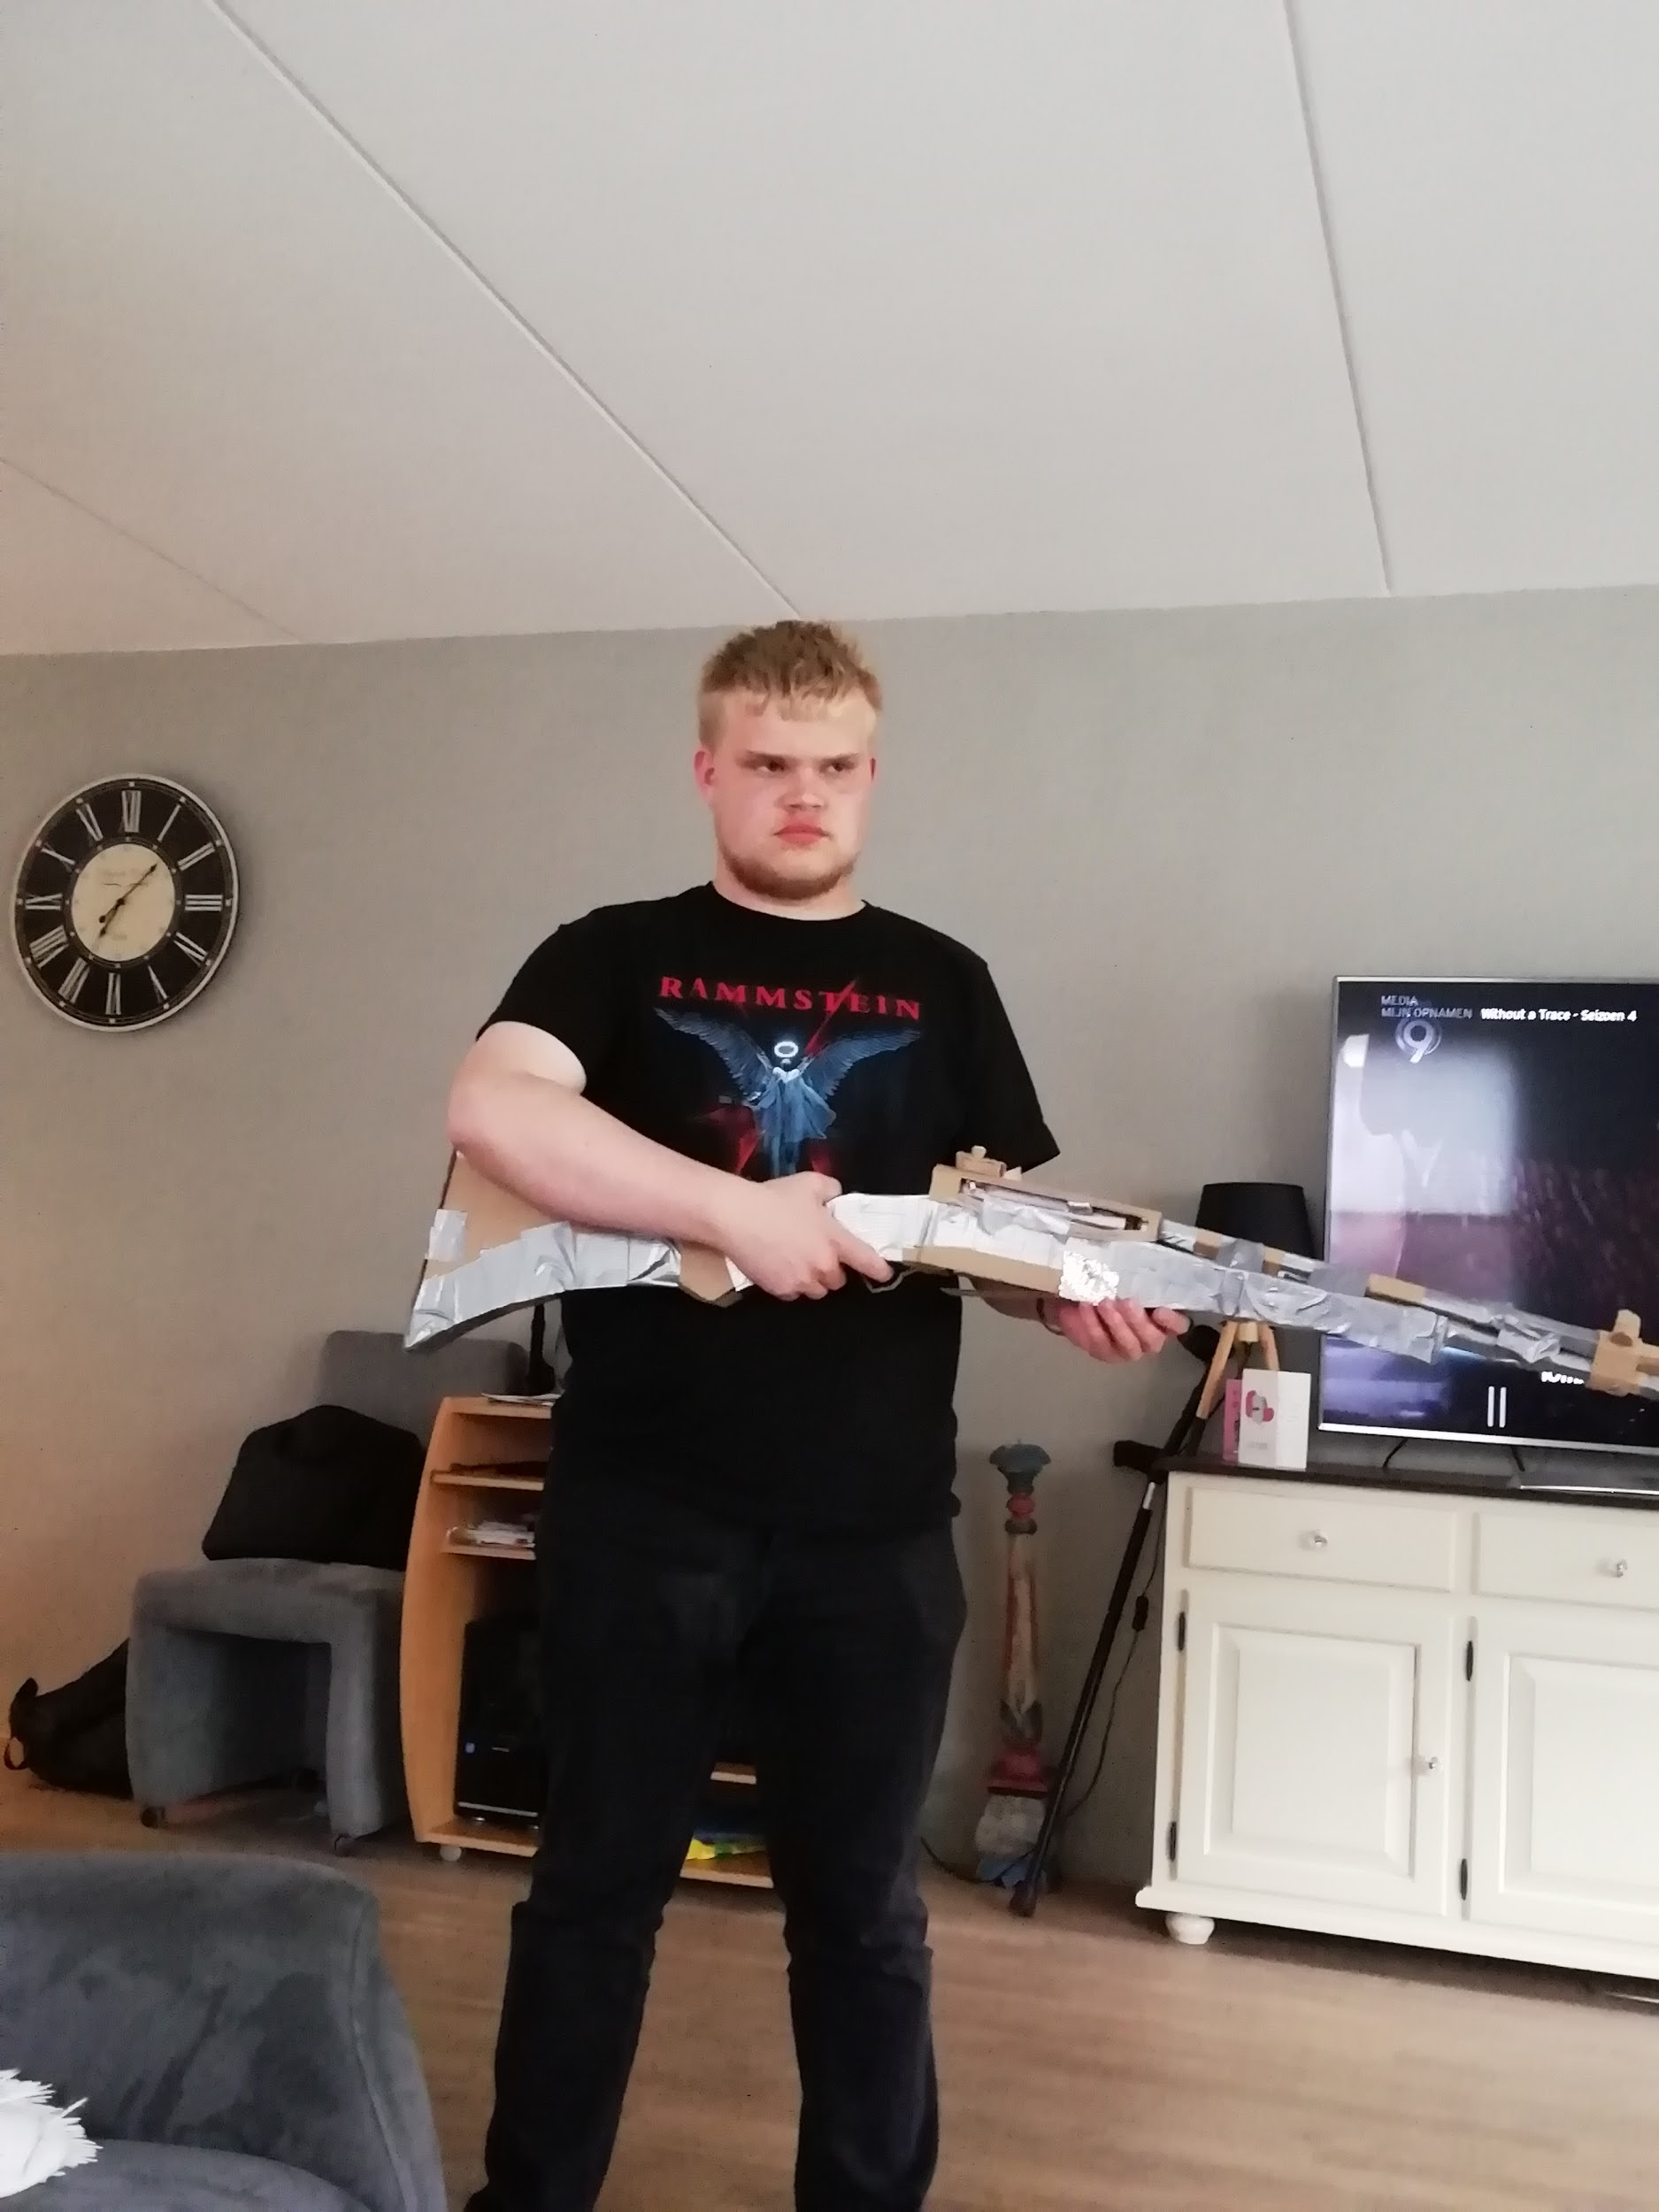

Overall conclusion is that a glue stick sucks and that builders glue is a better alternative. The schematic drawing helped me a lot during construction and was an actual near perfect design for what I wanted.

One of my proudest achievements.

Conclusion:

Overall it was a very fun project. I feel like I really showed my skill as a programmer and as a designer of games and hardware. It was a shame that the game was not finished but I am proud of myself for the professionalism shown during the project. I achieved most of my goals and did not relent when I faced a problem. Overall a good success but not a great one.